South Lake Middle School
Swim Team 2014
Coach: Mrs. Amy Way
away@solake.org
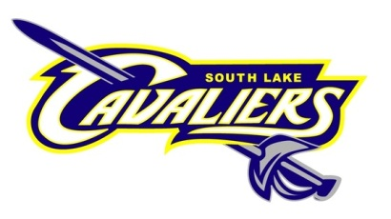
Welcome to our first-ever middle school swim program at South Lake! I’m very excited to help continue the tradition of success we have in our district’s swim programs. My name is Amy Way, and I’m the head coach for both our boys and girls varsity swim teams at South Lake High School. I am also a special education teacher at the high school (you can find me in Room 110). I have coached high school swimming for 4 years. I was a four-year swimmer in high school, and I competed at the collegiate level for Grand Valley State University.

Our team is open to 6th, 7th, and 8th grade students. No prior competitive swimming experience is necessary – we will work with you and teach you all four competitive strokes! In addition to Coach Way, several current and former high school swimmers will be joining us to assist with our team. We are looking forward to providing a fun athletic opportunity for our middle school students, and also aiming to build on our already successful girls and boys high school teams.

**All students MUST have a physical on file in order to participate – this is a state-wide requirement for all student athletes**

Our middle school season will begin on April 28 and will last for 4 weeks. Students will walk to the high school and practice at the high school pool. Please enter the pool using Door 5 off the main parking lot; it will be unlocked for swimmers only. A season calendar is provided with practice times and dates. Please be aware of practice ending times – coaches cannot leave the building until all students are picked up.

All team documents will be posted on my website: http://mrswaySLHS.weebly.com. You can also follow Coach Way on Twitter @CoachWaySL for the latest updates.

